Michael Black

Syed Haider

Sarah Han

Greg Violan

Output for the Views

1. Customer_v – for each customer, indicate his or her name as well as the customer type (prospect, steady or premier) as well as the number of years that customer has been with us.

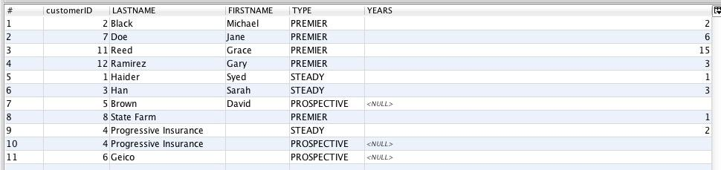

2. Customer_addresses_v – for each customer, indicate whether they are an individual or a corporate account, and display all of the addresses that we are managing for that customer.

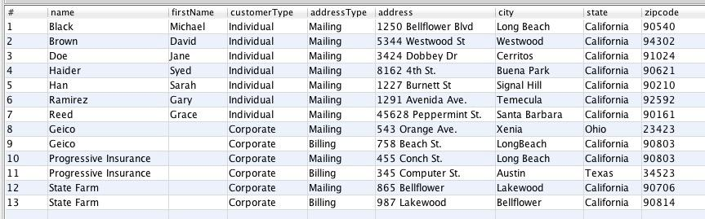

3. Mechanic_mentor_v – reports all of the mentor/mentee relationships at Dave’s, sorted by the name of the mentor, then the name of the mentee.

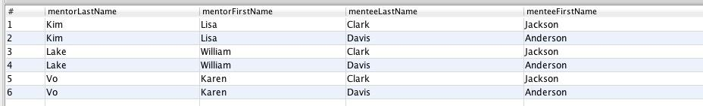

4. Premier_profits_v – On a year by year basis, show the premier customer’s outlay versus what they would have been charged for the services which they received had they merely been steady customers.

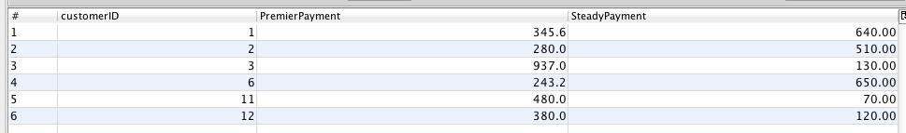

5. Prospective_resurrection_v – List all of the prospective customers who have had three or more contacts, and for whom the most recent contact was more than a year ago. They might be ripe for another attempt.  
